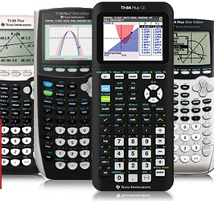AP Statistics

Please have purchased before the beginning of school:

* 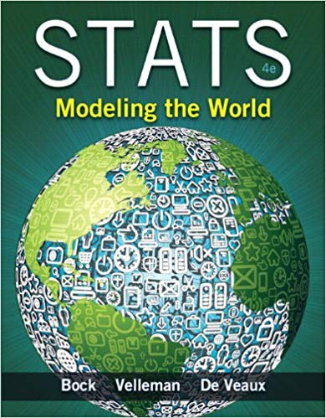TI-84 or higher model calculator (the TI-83 does not have all features for AP Statistics)
* **Textbook**: Stats Modeling the World 4e by Bock, Velleman, and De Veaux

ISBN: 9780133151541.

**Coursework**

This course will introduce students to the major concepts and tools for collecting, analyzing, and drawing conclusions from data. This class covers 4 main topics.

1. Data Analysis (25%)- Creating and interpreting dotplots, scatterplots, stem-and-leaf-plots, histograms, boxplots, bar charts, etc; calculating mean, median, standard deviation, and variance by hand and with a calculator
2. Experimental Design (15%)- Creating surveys and experiments using: sampling methods, bias, designing experiments, simulations, etc.
3. Probability (25%)- Using probability models, frequency tables, probability formulas, sampling distributions, and random variables
4. Inference (35%)- Creating and interpreting confidence intervals and hypothesis tests for proportions, counts, linear regression, and means.

**Summer Homework:**

All AP Statistics students should complete the summer homework which can be found on the counseling department’s homepage under summer homework before the first day of school.